Damage Monitoring and Tracking System
  - System Modeling Blueprint
This blueprint applies structural and behavioral modeling to the proposed agricultural damage reporting system. It documents the system components, user goals, report review workflow, and the path that report data follows from submission to farmer tracking.

Project Identification
Proposal title: Damage Monitoring and Tracking System
Project summary: The system allows farmers to submit crop damage incidents with farm details, observed severity, incident time, notes, GPS location, and photo evidence or a saved crop scan. MAO staff review each report, update its status, record remarks and actions taken, and farmers track the latest decision and report details.

Selected Diagrams
View | Selected diagram | What it documents
Structural | System Architecture | The React client, Express API, database, photo storage and notification connections.
Behavioral 1 | Use Case | Farmer and MAO staff goals within the feature boundary.
Behavioral 2 | Activity | A report submission, validation, staff decision and tracking scenario.

Data flow at a glance
Farmer input and evidence → API validation → report and photo storage → MAO review and history → updated report status and feedback returned to My Reports.

Structural Blueprint
The system architecture shows the fixed application parts and the connections used to submit, store, review and return damage reports.
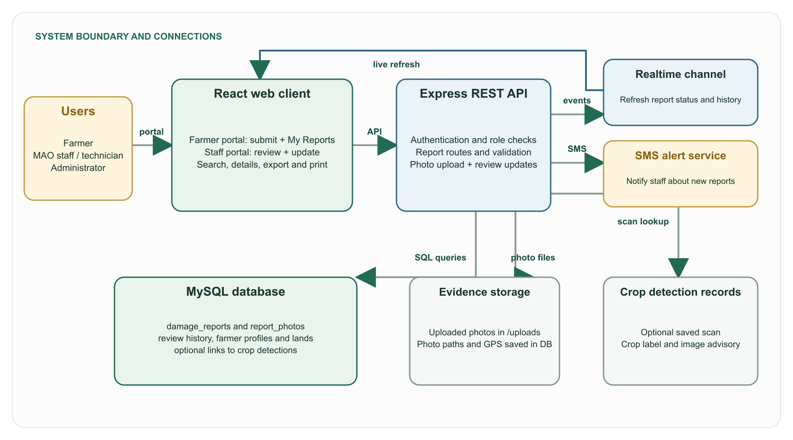
Figure 1. System architecture for damage monitoring and tracking.
Why this diagram is essential: It identifies where each feature runs and how report data, photo files, status events and alerts cross system boundaries. This layout guides implementation of the client, API, database schema and storage connections.

Behavioral Blueprint One
The use case diagram defines the feature scope through the goals of the two primary user groups.
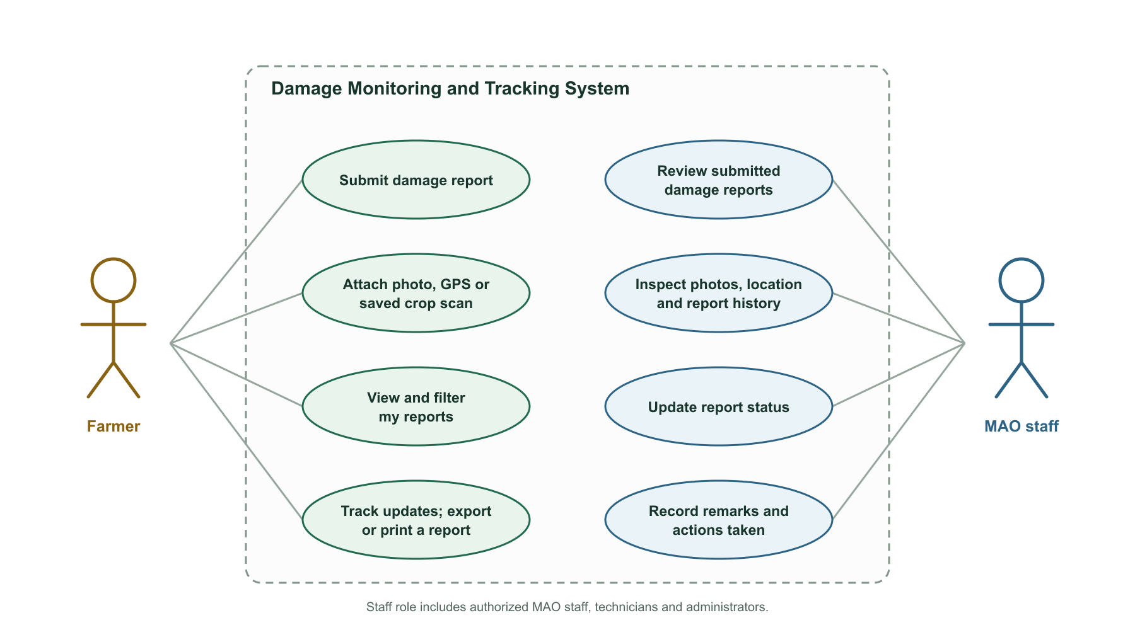
Figure 2. Use cases for farmers and MAO staff.
Scenario mapped: A farmer submits and tracks a damage report, while MAO staff review its evidence, set the report status, and record feedback. The staff actor covers authorized MAO staff, technicians and administrators.

Behavioral Blueprint Two
The activity diagram follows one damage report through validation, review and status tracking.
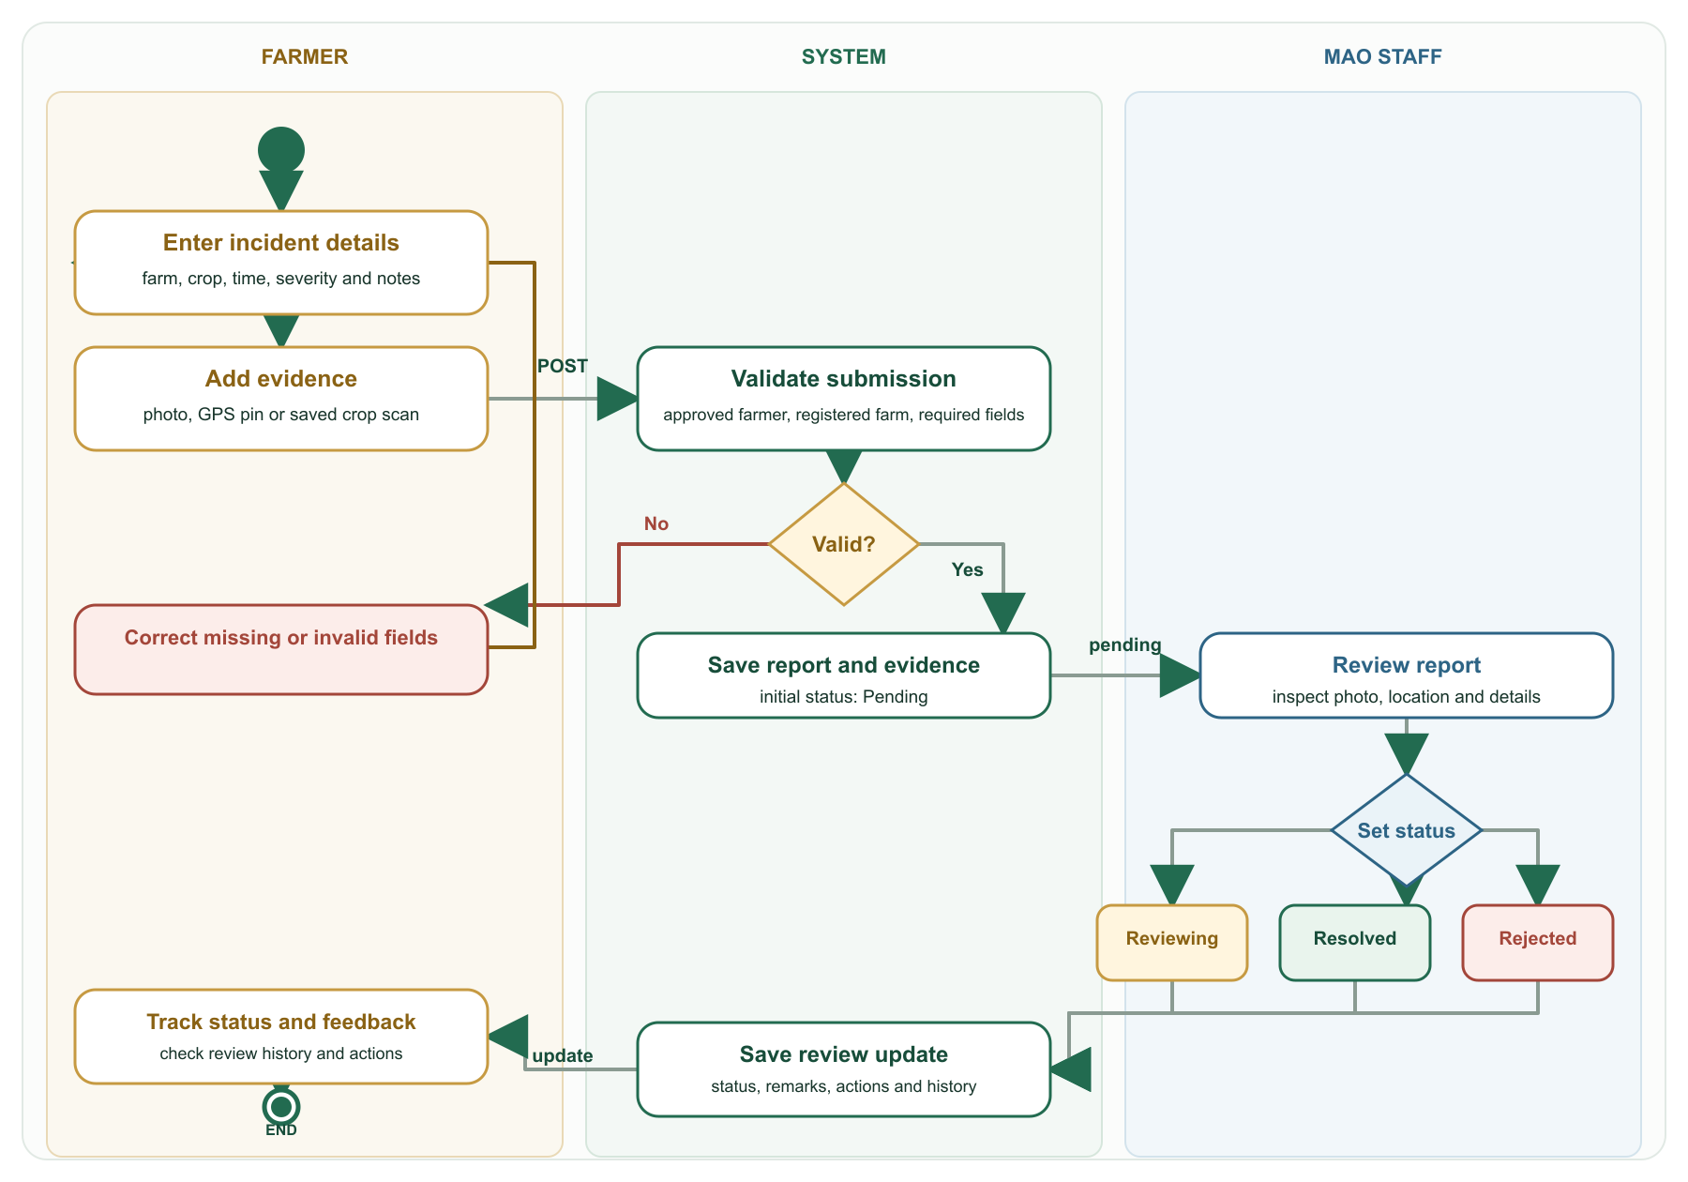
Figure 3. Activity flow from farmer submission to report tracking.

Data Blueprinting
Report information moves through authenticated submission, validation, database storage, staff review and retrieval by the farmer.
- Input. The signed-in farmer selects a registered farm and enters crop, damage type, severity, incident time, notes, location and photo evidence. A saved crop scan can be linked when available.
- Validate. The Express API checks that the farmer is approved, the farm belongs to that farmer, any linked scan is in the farmer's history, and required report fields are valid.
- Store. Uploaded image files are saved under server upload storage. The report, image paths and location metadata are written to MySQL.
- Review. MAO staff load reports and submit status changes with remarks or actions taken. The system saves each decision in the review history.
- Return. My Reports retrieves the farmer's report details and latest status. Realtime refresh updates the page, and a new report can trigger an SMS alert for staff.

Main data stores
Data store | Information used by the feature
damage_reports | Farmer, farm, incident details, severity, AI advisory fields and current status.
report_photos | Photo file paths, capture time and optional GPS coordinates.
damage_report_review_history | Reviewer, status changes, remarks, actions taken and review time.

Report status lifecycle
Pending → Reviewing → Resolved or Rejected. Each staff review can save remarks and actions so the farmer can see the latest response with the report.

